DIY Morse Code Flasher

Description:
The DIY Morse Code Flasher project is designed to transmit messages using light and sound signals based on Morse code.
In this project, an LED flashes and a buzzer beep in short and long intervals representing dots and dashes.
A push button is used to manually trigger the Morse code signal.
This project helps students understand basic communication systems, timing control, and input–output interfacing using Arduino.
Block Diagram:
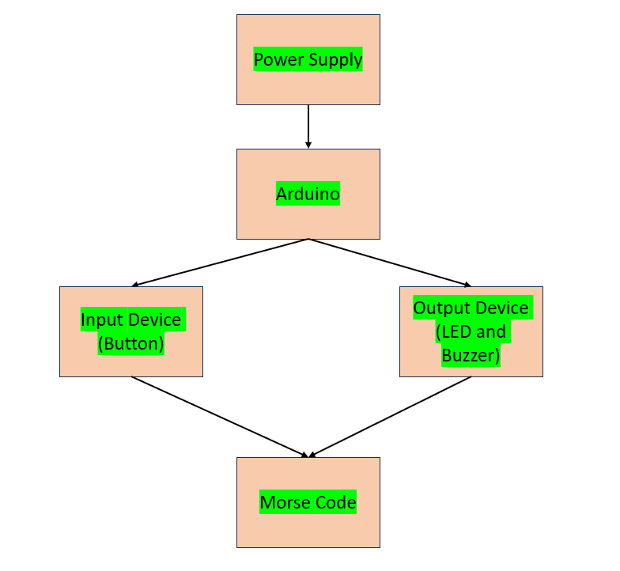
Pinout / Circuit Connection:
Arduino Pin 13 → LED (with 220Ω resistor)
LED Cathode → GND
Arduino Pin 8 → Buzzer (+)
Buzzer (–) → GND
Arduino Pin 2 → Push Button
Push Button (other terminal) → GND
Power supply: 5V (from Arduino USB or adapter)

Components Required:
Arduino Uno
1 x LED
1 x 220Ω Resistor
1 x Buzzer
1 x Push Button
Jumper wires
Breadboard

Working Principle:
The project works on the principle of timed digital output signals.
The push button acts as an input to the Arduino.
When the button is pressed, the Arduino activates the LED and buzzer.
Short ON durations represent dots, and long ON durations represent dashes in Morse code.
By controlling the timing, the Arduino transmits a predefined Morse code message.
Operation (Step-by-Step):
- Connect the LED, buzzer, and push button to the Arduino as per the circuit diagram.
- Upload the Morse code flasher program to the Arduino board.
- Power ON the Arduino using USB or adapter.
- Press the push button to start transmission.
- The LED flashes and buzzer beeps in Morse code pattern.
- The message repeats whenever the button is pressed.

Arduino Code:
int ledPin = 13;
int buzzerPin = 8;
int buttonPin = 2;

void dot() {
digitalWrite(ledPin, HIGH);
digitalWrite(buzzerPin, HIGH);
delay(250);
digitalWrite(ledPin, LOW);
digitalWrite(buzzerPin, LOW);
delay(250);
}

void dash() {
digitalWrite(ledPin, HIGH);
digitalWrite(buzzerPin, HIGH);
delay(750);
digitalWrite(ledPin, LOW);
digitalWrite(buzzerPin, LOW);
delay(250);
}

void setup() {
pinMode(ledPin, OUTPUT);
pinMode(buzzerPin, OUTPUT);
pinMode(buttonPin, INPUT_PULLUP);
}

void loop() {
if (digitalRead(buttonPin) == LOW) { // Button pressed
// Morse code for SOS (··· --- ···)
dot();
dot();
dot();

delay(500);

dash();
dash();
dash();

delay(500);

dot();
dot();
dot();

delay(2000);
}
}

Conclusion: (Predefined/self-written)
The DIY Morse Code Flasher project demonstrates basic digital communication using light and sound signals.
It helps learners understand timing control, signaling techniques, and Arduino input–output interfacing.
This project forms a foundation for advanced communication and alert systems.

For Your References:
[1] Arduino, “Blink Example,” Arduino.cc. [Online]. Available: https://www.arduino.cc/en/Tutorial/BuiltInExamples/Blink. [Accessed: Jan. 10, 2026].
[2] International Telecommunication Union (ITU), “Morse Code Signals,” ITU Publications. [Online]. Available: https://www.itu.int/rec/R-REC-M.1677. [Accessed: Jan. 10, 2026].

